# Apply filters to SQL queries

## Project description

In this project we are going to analyze data from SQL database using SQL queries, specially using AND, OR and NOT operators to create better filters and get more specific information about employees, their machines and the departments they belong to from the database.

## Retrieve after hours failed login attempts

Here we want to get login times that are after ‘18:00’ that are not a success so we can use this query `SELECT * FROM log_in_attempts WHERE login_time > ‘18:00’ AND success = FALSE;`  
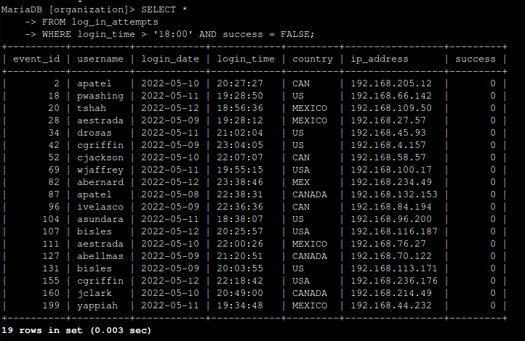  
And we can see there were 19 attempts after 18:00.

## Retrieve login attempts on specific dates

Now, we want to get all the login attempts that are at these 2 dates ‘2022-05-09’, ‘2022-05-08’, in this case we can use the OR operator since we are looking for either 09 or 08 so the query will be `SELECT * FROM log_in_attempts WHERE login_date = '2022-05-08' OR login_date = '2022-05-09';`

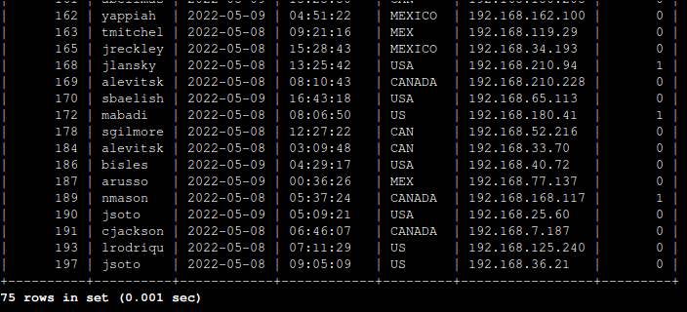

## Retrieve login attempts outside of Mexico

We want to get login attempts outside of Mexico, but MEXICO can also be MEX so we can use matching patterns such as ‘MEX%’ which means anything that start with MEX, this will consider all data, now we need to select all data from log_in_attemps where a country is not equal to anything that starts with MEX, converting this into SQL query we get `SELECT * FROM log_in_attempts WHERE NOT country LIKE 'MEX%';`

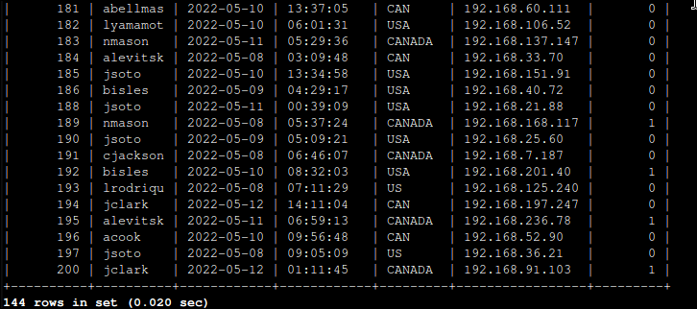

We get 144 login attempts

## Retrieve employees in Marketing

We need to get the employees who are in the ‘Marketing’ department and they are in the East buildings, because the given information must be together. We can use AND operator and we can use LIKE with pattern matching that gets all offices that start with the word ‘East’.  
`SELECT * FROM employees WHERE department = ‘Marketing’ AND office = ‘East%’;`

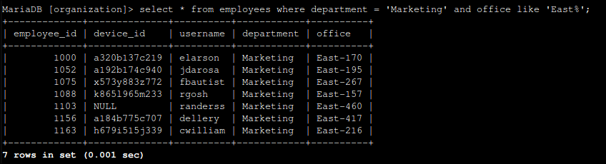

First employee appears to be ‘elarson’.

## Retrieve employees in Finance or Sales

In this part we only need the employees that are either in Finance or Sales, so basically we use OR operator here.  
`SELECT * FROM employees WHERE department = 'Sales' OR department = 'Finance';`

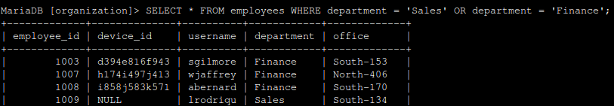

First Sales person is lrodriqu.

## Retrieve all employees not in IT

This time we just need all employees that are not in ‘Information Technology’ so we can use the NOT operator.

`SELECT * FROM employees WHERE NOT department = 'Information Technology';`

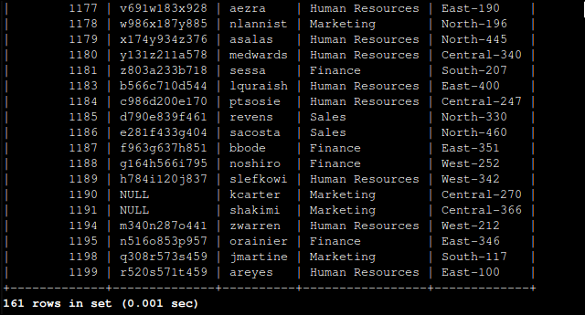

There are 161 employees that are not in the IT department.

## Summary

In this project, we explored three operators AND, OR, and NOT to filter employee data effectively from a SQL database. By applying these operators, we retrieved specific information about login attempts and employee details based on various criteria.